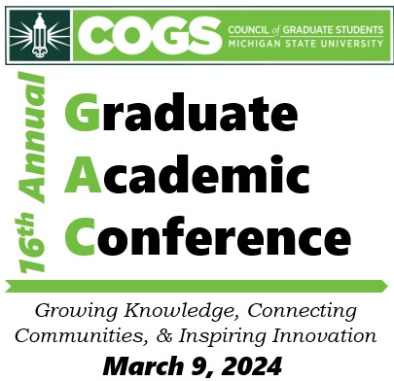
2024 Graduate Academic Conference
Advisor’s Endorsement of
Students Participation

Conference Date: Saturday, March 9, 2024

Presentation Title: __________________________________

Presenters Name: ___________________________________

Advisor’s Name: ____________________________________

To the advisor: Signing this form indicates that you endorse the student’s participation at 2024 Graduate Academic Conference. The student should be on campus in the spring of 2024 to present their research at the conference. A signed copy of this letter must be submitted with the student’s application to the conference.


____________________
Advisor’s Signature

____________________
Date

Email: office@cogs.msu.edu Phone : (517)353-9189

